**Properties & Structure of Atoms – Notes**

Ar = ∑(decimal abundance x isotopic mass)

In a discharge tube, the electrons of the atoms are being **continually excited from their stable state to higher energy levels as they gain energy, becoming unstable**. As the excited electrons return to lower energy levels, they **emit the excess energy as photons of specific wavelengths, becoming stable**. Since only specific electron transitions are possible, **only photons of specific energies are emitted**. These correspond to different wavelengths of radiation, some of which are in the visible light range.

When the barium ions are heated, the electrons absorb energy and jump up to higher energy levels. (1) As this state is unstable, the electrons eventually fall back down to their original levels and in doing so emit the energy they absorbed in the form of photons of light. (1) The wavelength of these photons corresponds to the wavelength of green coloured light. (1)

Flame colours are the result of visible radiation emitted by the **excited electrons falling to their original ground state** within the metallic ions as the electrons **emit excess energy which they gained, becoming stable**. Different atoms have different possible energy levels and hence any energy level transition is unique. This results in different colours being observed.

Flame tests are only qualitative. The colours may be masked by impurities. A Bunsen burner isn’t suitable for many metals due to its relatively low temperature.

The colours observed in a flame test are dependent only on the metallic ion.

First ionization energy < 2nd ionization energy < 3rd ionization energy.

Electrons are being removed from an increasingly positive ion rather than a neutral atom. Also, as each electron is removed, **the distance between the nucleus and the outermost electron decreases** and so electrostatic attraction increases. This results in an **increased amount of energy required** to remove an electron from the outermost electron shell.

Atomic size increases down a group:

As we go down a group, there’s an **extra shell of electrons** and thus the atomic radius becomes larger.

Ionisation energy decreases down a group:

As the atom gets larger, the **outermost electrons are further away from the nucleus, resulting in a decrease in electrostatic attraction** and so less energy is required to remove the outermost electron from the atom.

Atomic size decreases across a period:

As we go across a period, there are a **greater number of protons attracting the electrons**. Hence, the electrons move closer to the nucleus, resulting in a smaller atomic size.

Ionisation energy increases across a period:

As we go across a period, there are a **greater number of protons in the nucleus** and the electrons are more strongly held, causing the atomic radius to decrease. Hence, more energy is required to remove the outermost electron from the atom, resulting in an increase in ionization energy.

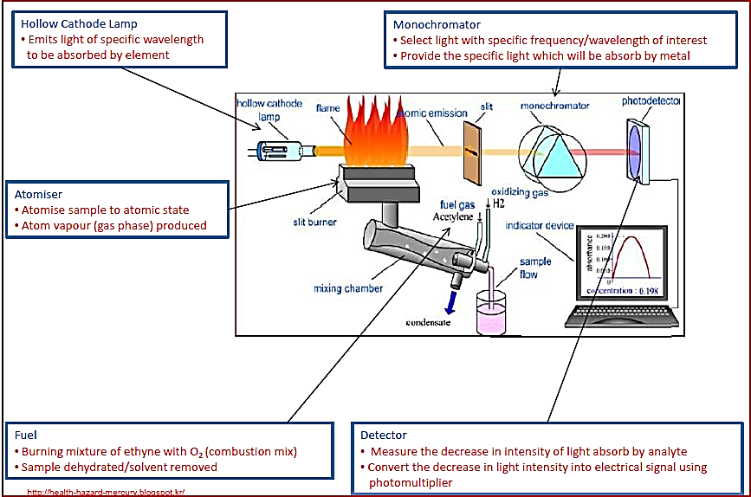

In the atomic absorption spectrometer, the **prism disperses the light** into its component colours, and the **monochromator allows only one wavelength to pass through** to the detector at a time.

The cathode of the hollow cathode lamp is **made with the metal being analysed** so that it **produces light containing the specific wavelength that can be absorbed by the metal sample** being analysed.

Emission spectrum – Formed when a sample of the element absorbs energy. The **electrons jump to higher energy levels, gaining energy and becoming unstable**, but then immediately will **drop back down** to their original energy level, releasing the excess energy and becoming stable. As the excited electrons return to their ground state, they **emit the energy they absorbed** in the form of photons of light of **specific wavelengths** (different colours).

Absorption spectrum – Formed when a sample of the element **absorbs energy from a light source**. As the ground state electrons absorb this particular wavelength of energy, a detector **measures its absence** (seen as a black line). Atomic absorption spectroscopy (AAS) uses this concept to determine the concentration of a known element in a sample.

* A **solution** containing the sample is first **atomised** in a hot flame.
* A beam of light **corresponding to the wavelengths of the sample** is passed through the atomised sample in the flame. To achieve this, the beam of light is produced by a hollow cathode lamp where the **cathode is made from the same element** as that being analysed.
* The monochromator then filters out other wavelengths of light emitted (removing noise) **except the one specific wavelength** being analysed.
* The **detector determines the intensity of the light being received.** The absorbance is the difference between the intensity of light emitted by the hollow cathode lamp and the intensity being detected. It’s proportional to the concentration of the sample in the solution.

AAS can be used to determine the **unknown concentration** of an element in a sample using a calibration curve.

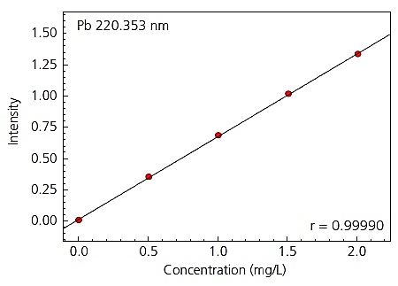

Mass spectrometry can be used to determine the **identity of compounds or elements** in a sample or determine the **isotopic composition** of an element.

There are 5 main processes involved in mass spectrometry:

* Vaporisation – The sample is made **gaseous** in a vacuum chamber.
* Ionisation – The gaseous sample is **bombarded by electrons** which causes it to **form ions**.
* Acceleration – The ions are **accelerated** through an electric field.
* Deflection – The ions then move into a magnetic field where they’re deflected **based on their mass to charge ratio**; the heavier ions are deflected less.
* Detection – A **detector measures the number of ions of different mass** (based on **intensity** and **radius** of deflection of ions).

Empirical formula:

|  |  |
| --- | --- |
| **P**ercentage abundance (%) | **P**eter |
| **m** in 100g (g) | **M**ade |
| **n** (mol) | **N**asty |
| **R**atio | **R**abid |
| **R**ound | **R**abbits |

Ionisation energy: The amount of energy required to remove an electron from the **outermost electron shell** from an atom in the **gaseous state**.

**Isotopic composition**: The abundance of each isotope in a sample.